### Computer Science & Engineering (Artificial Intelligence & Machine Learning)

The Department of Computer Science and Engineering with Specialization in Artificial Intelligence and Machine Learning (CSE AIML) at ABES Engineering College Ghaziabad was established in the year 2022. The department offers a four-year full-time B.Tech program in CSE AIML, with a total intake of 180 students. The B.Tech program is accredited by the National Board of Accreditation (NBA). The department has well-qualified, experienced, and dynamic faculty members.

The Department has well-equipped labs with the necessary hardware and software to meet the curriculum and industry requirements. They have a Project Lab, Advanced Labs to harness the creative and innovative aspiring minds to put their imagination into reality.

The Department has tie-ups with industry partners to enhance student employability skills through in-house training, workshops, guest lectures, and alumni lectures. These collaborations enable students to work on industry-relevant projects based on their interests, fostering a culture of research and innovation. Students in the Department undergo In-house training which includes advanced training, skill enhancement training, and industrial training to bridge the gap between Industry and Academia. The department's focus is on providing students with practical exposure and real-world experience to prepare them for successful careers in the field of Computer Science and Engineering with Specialization in Artificial Intelligence and Machine Learning (CSE AIML).

### 

### WHY US

* Placement and Internship Opportunities: Offers from top companies like Google, Microsoft, Amazon, TCS, Capgemini, and valuable internship opportunities.
* Emphasis on practical and hands-on learning: Discuss project-based curricula, hackathons, coding challenges, and other opportunities for students to apply theoretical concepts and develop relevant skills.
* Active student chapters and communities: Highlight any active student chapters, clubs, or communities focused on specific technologies, coding, or entrepreneurship, which foster peer learning and networking.
* Support for entrepreneurship and innovation: If the department encourages and supports student startups, entrepreneurial ventures, or has an incubation center, mention those resources.
* Alumni success stories and mentorship: Share success stories of notable alumni, their career achievements, and any alumni mentorship or guidance programs available for current students.

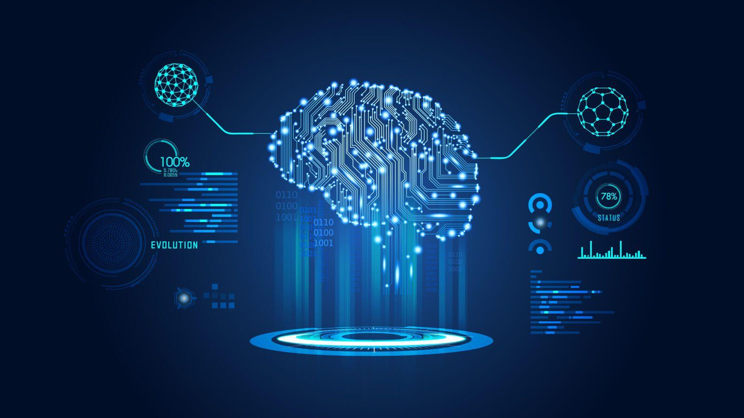

### **MOU's**

